Derwen News May 26
Drama Performance
I had the pleasure of watching the school Drama Club’s performance of Pirates v Mermaids last week. The children were absolutely fantastic and were a real credit to both the school and their families.
The children have been practicing since September, with many of them also performing in the school choir earlier in the year, and the commitment and dedication they have put into their roles and the final production has been amazing.
A huge thanks also to Mrs Cartwright and Mrs King who have spent hours helping the children achieve their goals.
I was also so proud of the children who decided to help raise funds to replace the battery for the community defibrillator located to the front of the school. The children helped raise funds through organising a raffle and selling bracelets that a group of our Year 6 girls have been making for the past couple of weeks.
A brilliant effort from all involved.

Sports Day - Wednesday June 7th

The children have had their practice for the annual sports day and are now looking forward to having their families join them on Wednesday June 7th for the actual event. Hopefully this lovely dry weather will continue for the sports day.

The Foundation Sports Day (Nursery to Year 2) will begin at 9.30am with the Nursery Class having their races at approximately 10am.

The Junior Sports Day (Years 3 to 6) will start at 1.15pm.

Both events will take place on the school field and it would be appreciated if you could ensure that your child is well protected from the sun by the use of sun cream and a sun hat if the weather is hot. Please also ensure that your child is sent to school with a full bottle of water which they can take with them throughout the events.

As in previous years the children will be working in teams to gain points for their House by undertaking in a number of activities. Please feel free to follow your child as they move around the activities and give them and their team your full support. We also hope to have a running track marked out for some running races.

We have reserved Monday June 12th as an alternative date if the weather is poor.

Any last-minute changes will be communicated to you via email.

Looking forward to a fun filled day!

Digital Café Session 3

In order to try and reach out into the community, Miss Ellingham and our Pupil Digital Leads are holding half termly Digital Café sessions at the school.

On Wednesday 21st June, the digital leaders will be holding their next “digital café” in the Year 6 Classroom.

The digital leaders will be using the skills they developed in the digital hero training to help members of the community increase their confidence with using different types of technology.

The session will run from 3.30 – 4.30pm.

The aim of the sessions will be to help any senior citizens within the village, or grandparents of our pupils, who would like some support with digital technology. Pupils will be able to help demonstrate common tasks such as writing and sending emails, how to take part in video calls/ meetings, working with Word/ Excel or any other issues they may need support with.

The sessions have been well attended so far so please help us continue to make this initiative a success by sharing this information with any senior citizen who may need some technical support.

The sessions are also planned as social / wellbeing events with tea/coffee and biscuits served!

Wellbeing Project

As communicated earlier this term, the children have been working on a number of wellbeing projects this year. The next project the children are now working on is to create a new wellbeing / sensory area on the school field. This area will be situated between the trim trail and the forest school site. The Eco Council have been working with Angela Done to draw up plans and have decided that they would like to create the new area using community support and by using predominately recycled materials.

We held our latest parental engagement session with parents of children in Year 3 last Tuesday and we were so pleased to have such a good turnout. We are hoping to hold the next parental engagement session on Monday June 26th and would like to ask any parents of children in the Juniors to make a note of the date if you feel you can spare some time on the day to help with a number of tasks such as painting, digging, relocating a shed/playhouse, lifting etc.

We will share more information about the arrangements for the day after half term.

If you feel you can support the Eco Council with this project, please be aware that they are still asking for donations of items to help bring their plans to fruition. The poster below outlines items they need to help develop the area.

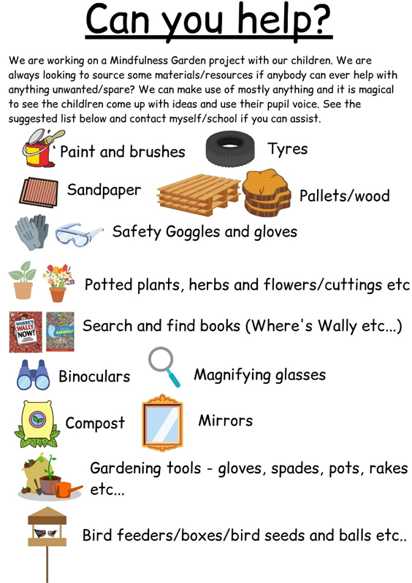
Any support with this project would be much appreciated

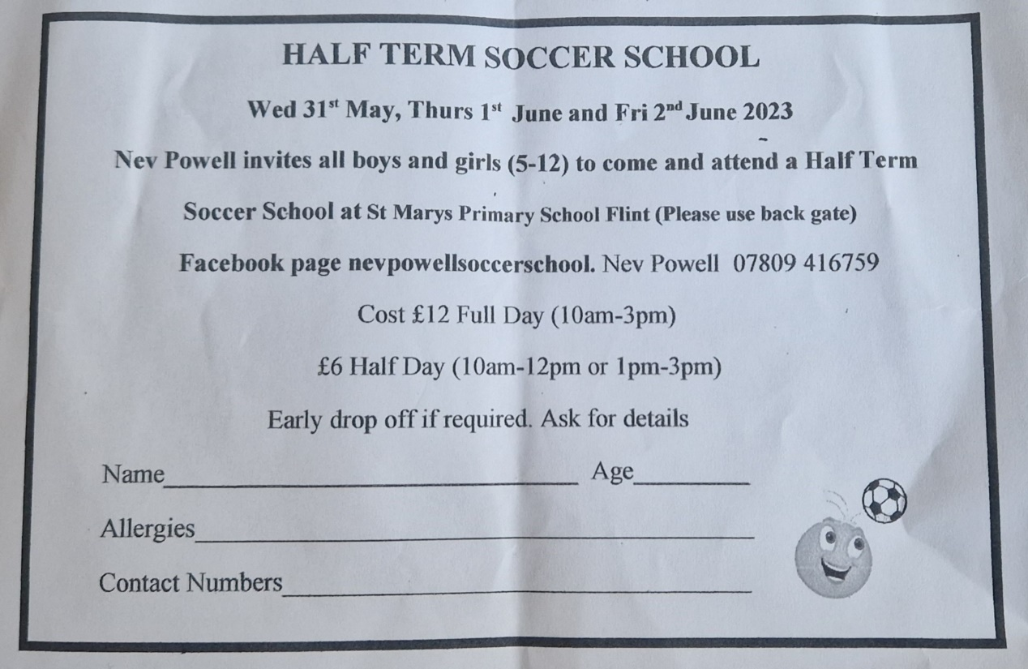

Have a great half term
Best Wishes for the Half Term Break. Everyone at Ysgol Derwen would like to wish you and your family a safe and relaxing half-term break and look forward to welcoming the children back to school on Monday 5th June.

Thank you for your continued support throughout this half term
R Jones

