Derwen News - February 28

St David’s Day Reminder– Friday March 1st 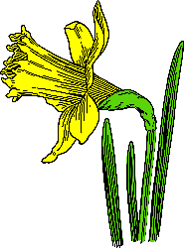

Non Uniform Day
To help celebrate St David’s Day on Friday March 1, the children will be undertaking in activities based on Welsh culture and heritage throughout the week.

Children can also come to school on Friday March 1st in non-uniform.

Children can if they wish dress in the national colours of Wales (Red, White and Green,) and also in traditional dress if you already have a costume. Children can also wear national emblems of Wales e.g. daffodil, leeks etc.

Menu Change
There will also be a change of menu on Thursday February 29 to help celebrate St David’s Day.

- The menu on the day will be:
- Pork and leek sausage, mash and greens
- Vegan sausage, mash and greens
- Bara Brith

World Book Day
We will be celebrating World Book Day on Friday March 8th.
If your child wants to dress as their favourite book character on this day,
they are welcome to come to school in their costume.

Alternatively, they can attend school in non-uniform. Some reading
themed activities will be taking place during the day and your child
can bring their favourite book in if they would like to.

FODS Disco – Thursday March 21st

- Foundation Phase - 3.05 - 4.15 pm
- Key Stage 2 - 4.30 - 5.30 pm

£3.75 per child -to include a drink, hot dog, packet of sweets, glow stick and tattoo.

Children may attend in own clothes. Children do not need to bring any additional money to the event.

Tickets from the postponed February disco will automatically be transferred to the new date however if you cannot make the new date please email FODS fodspta@gmail.com for a refund.

If there are any pupils who did not have tickets in February who now wish to attend please use the link below before 18th March.

Booking Link:

https://square.link/u/wuL9nI6p

Please use the schools main entrance on arrival and pick up will be by Year 1&2 entrance

We cannot guarantee places for any requests to attend the disco received after 18th March 2024. It will not be possible to pay on the door. Tickets will NOT be issued for this event

Should your child have any allergies/ special dietary requirements please email fodspta@gmail.com.

Please liaise with Little Acorns directly if your child will be attending after school club and the disco.

Aura Swimming Lessons
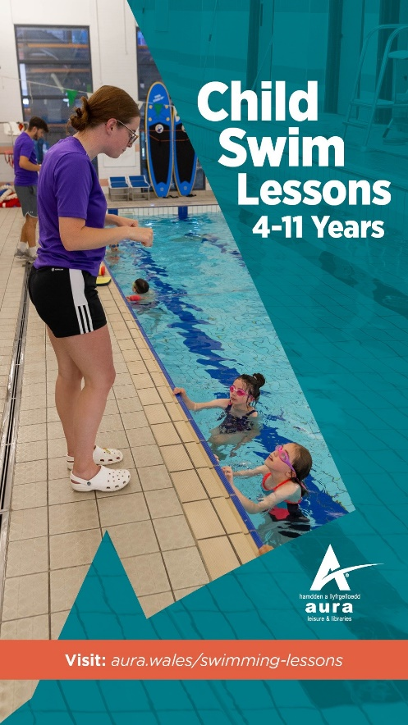

Measles Advice

We have been asked to draw your attention to the following information:

Following recent outbreaks of measles across the UK, Betsi Cadwaladr University Health Board is inviting children who are not fully protected against the disease to catch-up with their MMR vaccinations.

To reduce the risk of outbreaks, we want to ensure as many children throughout North Wales as possible are fully vaccinated.

Measles can be very disruptive for schools
- Measles is very highly contagious and can be passed on up to four days before symptoms fully develop or a rash appears
- In the event of a confirmed case of measles in a school, children and staff who are not fully vaccinated could be required to isolate for up to 21 days
- Extensive contact tracing would also be required to identify anyone potentially affected in school and the wider community
Measles Facts
- Measles is a highly infectious illness. It is contagious before symptoms start.

- For every 100 people not vaccinated against measles, about 90 will catch measles if exposed to the measles virus.

- It can cause serious illness including chest infections, seizures (fits), swelling of the brain, and brain damage. Serious complications can even occur many years after infection

- Measles can kill.

- There is no cure for measles.

- Children, young people and staff members are at risk of measles infection if they haven’t had 2 doses of the MMR vaccination or documented natural infection.

Eligibility for MMR vaccination

Two doses of the MMR vaccine are offered free to all children before they start school at:

• 12-13 months, and

• 3 years and 4 months.

Children and adults who miss any of the doses can still receive them from their GP surgery at any time after they were due, with a month needed between the two doses.

The MMR vaccine should not be given to people who have a lowered immune system or who are pregnant. This is even more reason to ensure that everyone who is eligible has received both MMR doses, to protect those who cannot have the MMR vaccine.

If you are not sure if you have had both doses, it is safer to have too many doses of the vaccine than not enough.

More information about the MMR vaccine and eligibility is available at phw.nhs.wales/MMRvaccine

Measles symptoms

- Rash
- Temperature (usually over 38.5°C)
- Runny nose
- Red, sore, watery eyes
- Cough

Measles usually starts with cold like symptoms. It can then be followed by a rash a few days later but not always. Sometimes people get small white spots on the insides of the cheeks and insides of lips that last a few days.

It is unlikely to be measles if you have had 2 doses of the MMR vaccine or had measles before, unless you have a condition or are on treatment which weakens the immune system.

What to do if you suspect measles

If you suspect you, or a child/young person has measles you can get advice from NHS 111 or you can make an urgent GP appointment.

The person with suspected measles should not go to any health setting (e.g., GP, hospital, or pharmacy) without ringing ahead first and advising of any symptoms which might suggest measles.

If a doctor suspects measles, the individual should stay off nursery, school, college or work etc. for at least 4 days after the onset of rash (Note: date the rash started is day 0). They should also avoid being in contact with anybody who is:
• Not fully vaccinated for MMR (particularly children under the age of 4).
• Pregnant.
• Immunosuppressed (has a weakened immune system) due to a health condition or treatment.

What are the risks of being unvaccinated against measles?

As measles is a highly infectious disease it spreads quickly between people who are not vaccinated.

Uptake of the MMR vaccine decreased in Europe during the COVID-19 pandemic which means we are now seeing an increase in cases of measles across the UK and in Wales.

Although not everybody with measles needs to be admitted to hospital, it is a very unpleasant illness even in its mildest form. There is no cure, and some people will be left with life changing brain damage. Serious, untreatable complications of measles can happen years after people have had the illness.

Staff or children/young people who are unvaccinated and who have been in contact with a confirmed measles case will be advised to stay at home for the duration of the incubation period. The incubation period is the time frame it takes for a disease to develop after coming into contact with it. For measles it is up to 21 days (3 weeks) after last exposure to someone with measles.

For more information about measles symptoms, visit NHS 111 Wales - Health A-Z : Measles

