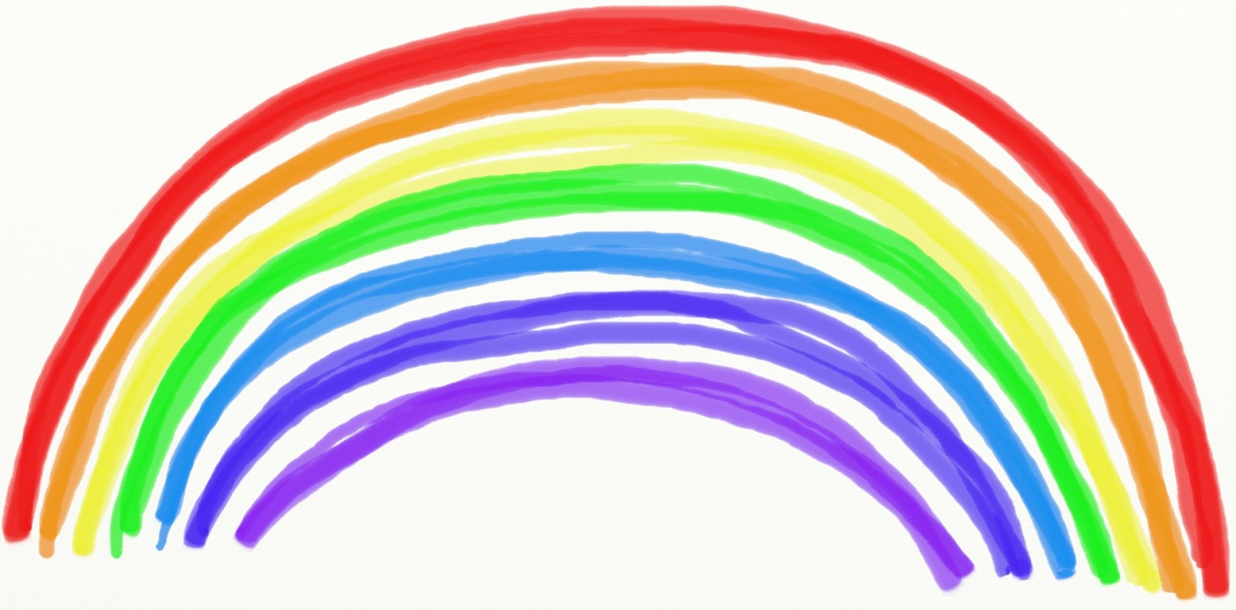

**Year of the lockdown 2020**

**We are so proud we were your teachers,**

**We watched you learn and grow.**

**We worked so hard and had such fun,**

**How fast did the time go?!**

**The year was interrupted,**

**It seemed too soon to part.**

**But know that you will always have,**

**a special place in our heart!**

**See you next year !**

**Love**

**Your teachers x**