ch, sh & th

 | _ _ ark
 | rubbi _ _
 | _ _ air
 | swit _ _
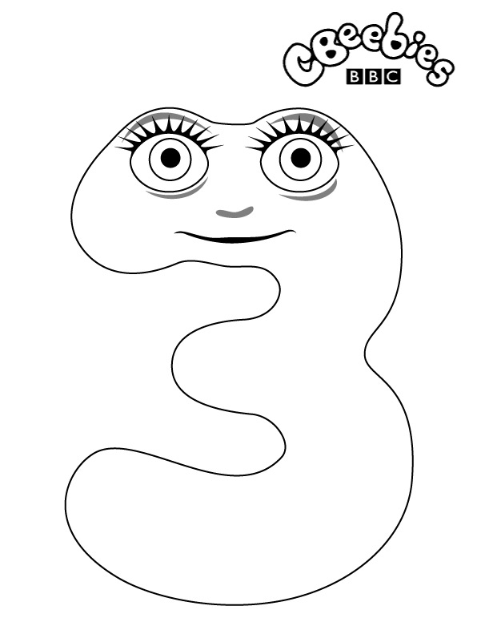 | _ _ ree
 | tee _ _

ch _ _ ips _ _ air _ _ eese

______ ______ _______

sh _ _ op _ _ed _ _ eep

_____ _____ ______

th _ _ under _ _ ink _ _ ree

________ ______ ______

