ch, sh or th

 | ba_ _
 | _ _ ed
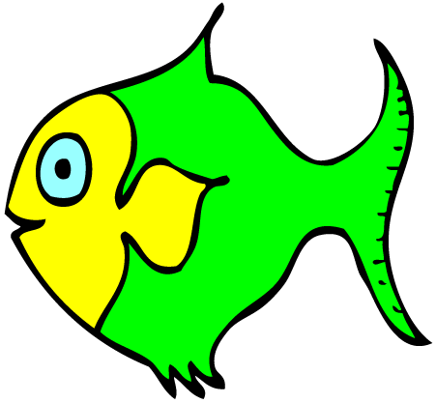 | fi _ _
 | _ _ ink
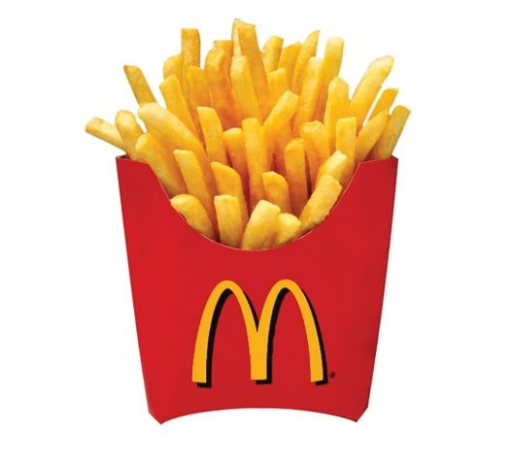 | _ _ ips
 | _ _ icken
 | ear _ _
 | wat _ _
 | bru _ _
 | tor _ _
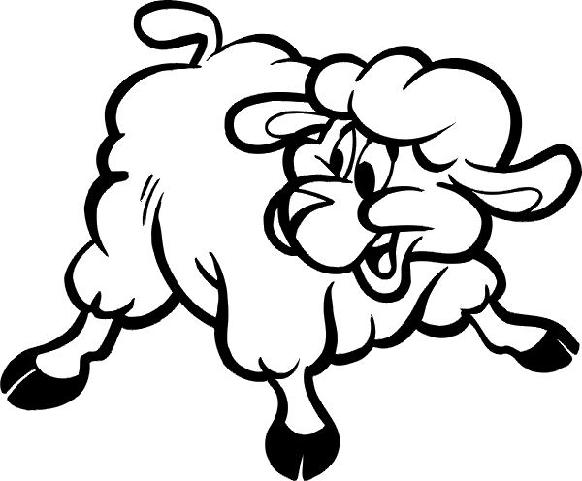 | _ _ eep
 | _ _ under
 | mou _ _
 | _ _ adow
 | _ _ ocolate

