oo, ee or ea

 | m _ _ n
 | b _ _ k
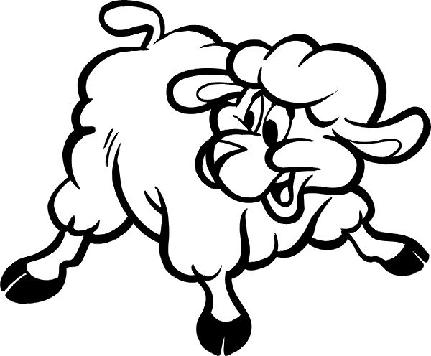 | sh _ _ p
 | cl _ _ n
 | h _ _ ver
 | t _ _ th
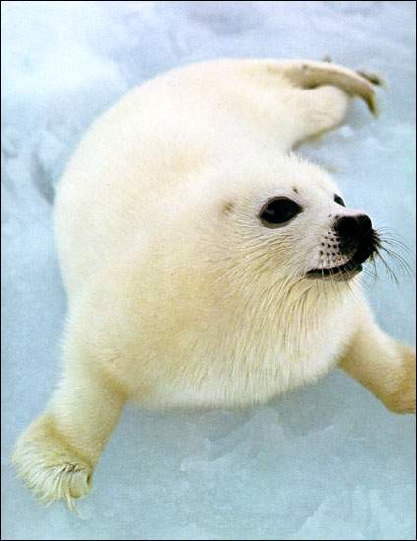 | s _ _ l
 | sl _ _ p
 | ball _ _ n
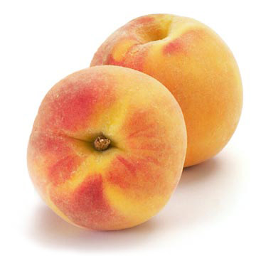 | p _ _ ch
 | l _ _ f
 | b _ _

